Cherry-Picking Evaluation Metrics: Report

Team: team_31  
Student IDs: (Nabanita Roy)17305618, (Abhimanyu Hazarika)17314158, (Bhavik Mer)17304936  
Total Time Required (in hours): 24 hours (approximately)

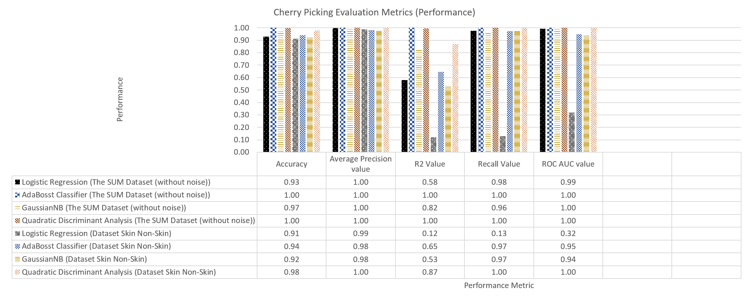

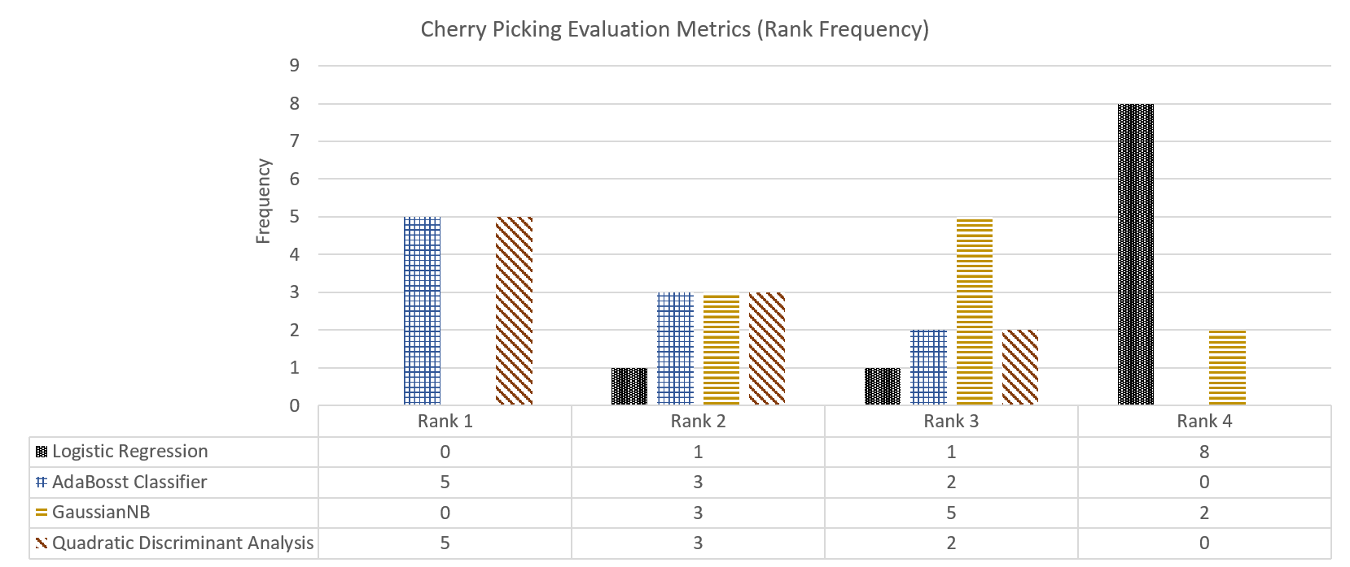

# Findings/Answer (200-300 words)

As suggested; we chose novel algorithm(Logistic Regression) randomly and compared the accuracy and precision of model based on two datasets namely Skin_NonSkin and SUM Dataset (without noise).

From the performance graph, it is clear that AdaBosst Classifier completely out-weigh the novel algorithm we chose by accuracy, average precision score, R2 value, Recall value and ROC_AUC value metrics. Explaining more about ROC AUC score is if the value is below the slope(45 degrees) in XY_plane the model was chosen is not proper where someone described it as ROC hell and value above the slope in XY_plane is ROC heaven. ROC also helps in understanding Confusion matrix which itself is a type of metric to evaluate the model.

Therefore, we learnt how metrics help in evalutating which is the best model to use for the given dataset we are working on. Understanding metrics helps us understand how machine learning algorithm works.

# Additional Information

While working on the metric evaluation, we did research on plotting graph and understanding the impact of accuracy based while changing tuning parameters of the functions. Especially, we learned that when k-neighbor, if the n_neighbor value is small it more complicated the model becomes. Optimal parameter decides by plotting accuracy graph against the n_neighbor range and see which value fits the given dataset more accurately with less noise. We used k- neighbor to explain how we performed analysis for the algorithm listed.

# Data, Algorithms, etc.

|  |  |
| --- | --- |
| **Novel Algorithm** | Logistic Regression |
| **Baseline Algorithm 1** | AdaBosst Classifier |
| **Baseline Algorithm 2** | GaussianNB |
| **Baseline Algorithm 3** | Quadratic Discriminant Analysis |
| **Dataset 1** | The SUM Dataset (without noise) |
| **Dataset 2** | Dataset Skin Non-Skin |
| **Common Metric 1** | Accuracy |
| **Common Metric 2** | Average Precision value |
| **Common Metric 3** | R2 Value |
| **Common Metric 4** | Recall Value |
| **Common Metric 5** | ROC AUC value |

# Contributions (max. 200 words)

17305618 worked on Gaussian Naive Bayes, 17314158 worked on AdaBosst Classifier, 17304936 worked on Quadratic Discriminant Analysis. The analysis of the datasets was already done as a apart of Task 1. In metrics, again we had already implemented ‘Accuracy’ so we worked on the rest of metrics. 17305618 worked on ‘Average Precision Value’, 17314158 worked on ‘R2 Value’ and 17304936 worked on ‘Recall Value’ and ‘ROC AUC value’. 17305618 worked in major on creating the CSV files, 17314158 in major focused on integrating code and 17304936 worked on the final Report. To summarize, we worked as a team, delegated tasks equally and helped each other to accomplish the task. All three of us brainstormed to create new metrics but was unsuccessful.